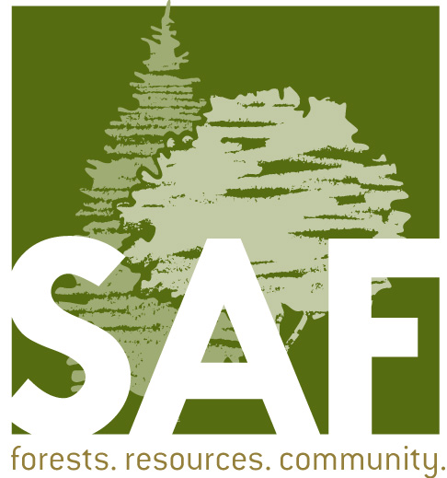

Capitol Chapter
2016 Spring and Summer Events

March 15 Ballots due to NW Office

March 30 Chapter Meeting
4-5pm Santiam Brewing Company
2544 19th St SE, Salem

April 27-29 OSAF Annual Meeting
Coos Bay
Registration/Information at forestry.org

May 25 Chapter Meeting
4-5pm North Dallas Grill
170 E Ellendale Ave, Dallas

June 25 Capitol Chapter Annual Family Picnic
Thank You Berry Much Farms!
Blueberries, BBQ, Beverages and Foresters
Hosted by Mike and Cristina Wheeler
5975 Culver Drive SE, Salem

July/August TBA- Joint event with Oregon Small Woodlands Association

September 21 Chapter Meeting
4-5pm Seven Brides Brewing
990 N 1st St, Silverton

